Rotary Club of Kathmandu Mid-Town
Breakfast Chatter



6 October 2006 The Weekly Bulletin of Rotary Club of Kathmandu Mid-Town Bc # 14 of 2006-07

District : 3290 Web: www.rotarymidtown.org.np Club Id : 26776

OCTOBER IS VOCATIONAL SERVICE MONTH
People join Rotary clubs as proud representatives of their businesses or professions. Hence, all club members have an obligation to represent their vocations to fellow Rotarians and exemplify the spirit of Rotary in the workplace. These twin responsibilities form the foundation of Vocational Service.

Dashain Festival :
This year 2006 Dashain festival is now almost over. It started with Gatasthapana on Saturday, 23 Sept 2006. On 29 Sept was the Phoolpati followed by Maha-astami on 30 Sept and Maha-nawami on 1 Oct.
Dashain is a time for introspection as it stresses such eternal virtues as truth, love, compassion, fellow-feeling, universal goodwill, and shedding of jealousies and prejudices.
Vijaya Dashami symbolises the triumph of good over evil, truth over falsehood, and light over darkness. During nine days of Dashain, Goddess Bhagawati, the symbol of shakti, is worshipped. On the tenth day, that is, on Vijaya Dashami day, devotees receive jamara and tika from elders as Bhagawati's prasad and blessings. Visiting elders to receive tika and jamara and blessings on Vijaya Dashami and the following four days has become a time-honoured tradition.

There was no weekly meeting on Friday 29 Sept 2006. It was Dashain holiday.
Each of the Mid-Towners must have had grand celebration of Dashain with the familities, friends and near and dear ones. One has to wait one full year to celebrate another Dashain in 2064 !

Weekly Meetings and Programs :
Date | Program/Speaker | Program/Topics of Presentation
6 October 2006 | Rtn Badan L Nyachhyon | Urban concern: waste free communities
13 October 2006 | Dr Bijay K C | Management challenges
20 October 2006 | Dr Isabella C B'nana Khadka | Past Reminiscences and Present Musings

Friday, 6 October morning :
Rtn Badan L Nyachhyon will be talking on one of the major issues of urban living: waste management. He will provide insights into urban concern for improving quality of life in urban living, inevitable need for developing waste free communities and Rotary's roles in such endeavours. It is a fact that society generates waste which tends to increase with growth in living standard of people in the society. Waste management may take one of the following approaches: a) dumping in nature, b) collection and transfer to landfill site, c) sanitary landfill with segregation, d) waste reduction at source, and e) waste management at source.
The concept of waste management at source is popularly known as zero waste concept which inherently consist of six elements: avoiding bringing home unnecessary items, production of clean waste, sending back the waste to its original source of generation, banning disposal of the waste in public place or nature, mass participation by the communities for management of waste source, and continued rethinking on the methods of final disposal.

Club Activity : Bowling
Mid-Towners, how good are you in bowling ? A joint bowling program with Rotaracts has been fixed on 14 October, Saturday morning. It will be sort of bowling fun with Rotaracts. If you are not very good, you better start practising forthwith. Else Rotaracts will take all the prizes away. And what will have you : of course, pride in our Rotaracts !

Girl Child Education Project at Tistung (MG-51107) :
President CK Golchha, PE Walter Diller, Community Service Director Peter Clawson, Vocational Service Director Govinda Chipalu, International Service Director Saroj Shrestha and Rtn Navyo Eller visited Janata Primary School and Tistung Deurali Nepal Chamber Primary School at Tisting on 21 September 2006 and distributed dresses, shoes, pairs of shocks, bags and stationery items to students of the Schools. Teachers and students seemed to be very happy to meeting the visiting Rotarians and for the assistance provided.
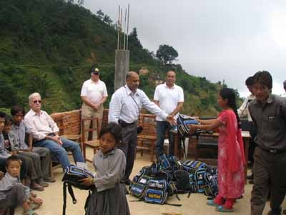
President CK handing over school bags to students

Congratulations to Ambica-didi for your being the major donor of the club.
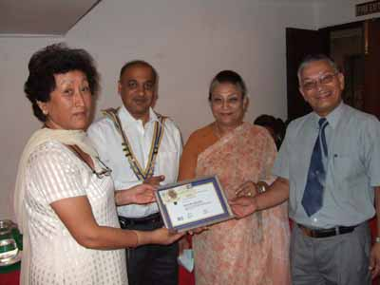
PP Ambica Shrestha receiving Major Donor certificate from AG Dr C Lekha Tuladhar
on 22 Sept 2006 at the club meeting.

Rotary is about showing the world the better way. It's about making a promise to our communities that we will be the kind of people who listen before we speak, who think before we act, who value integrity and unselfishness above profit or convenience.
RI President William B. Boyd

6 October 2006 The Weekly Bulletin of Rotary Club of Kathmandu Mid-Town Bc # 14 of 2006-07

Editor: RR Shrestha, Club Service Director email: rryes@wlink.com.np

